Go to Illuminate. Then select view Assessments.
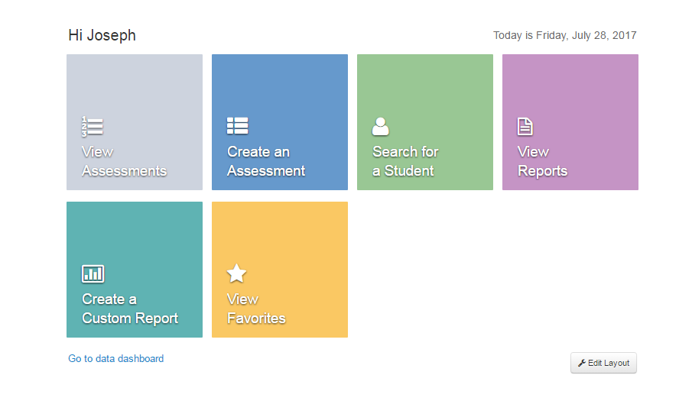
Then you want to search for “Digital Citizenship” (clear any filters)
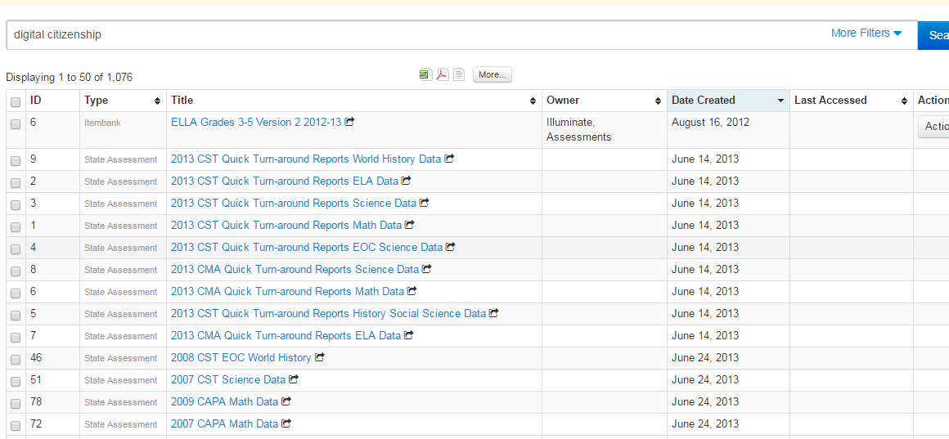
Click the assessments you want which should then bring up this menu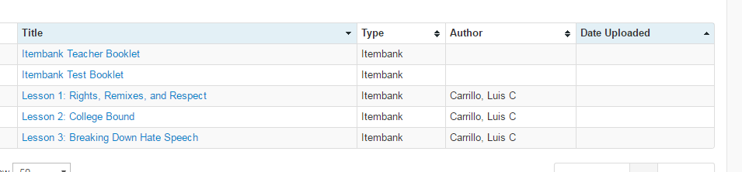
Then click the information you need.

